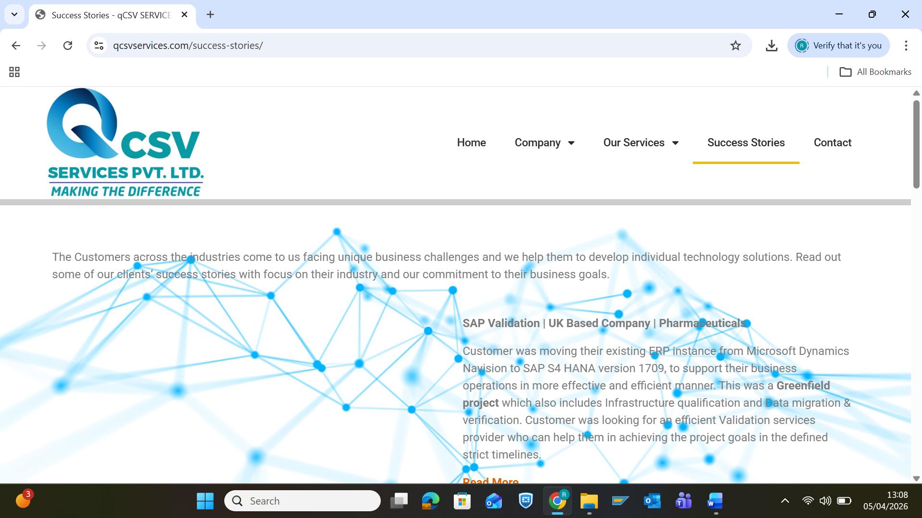
The Customers across the industries come to us facing unique business challenges and we help them to develop individual technology solutions. Read out some of our clients’ success stories with focus on their industry and our commitment to their business goals.
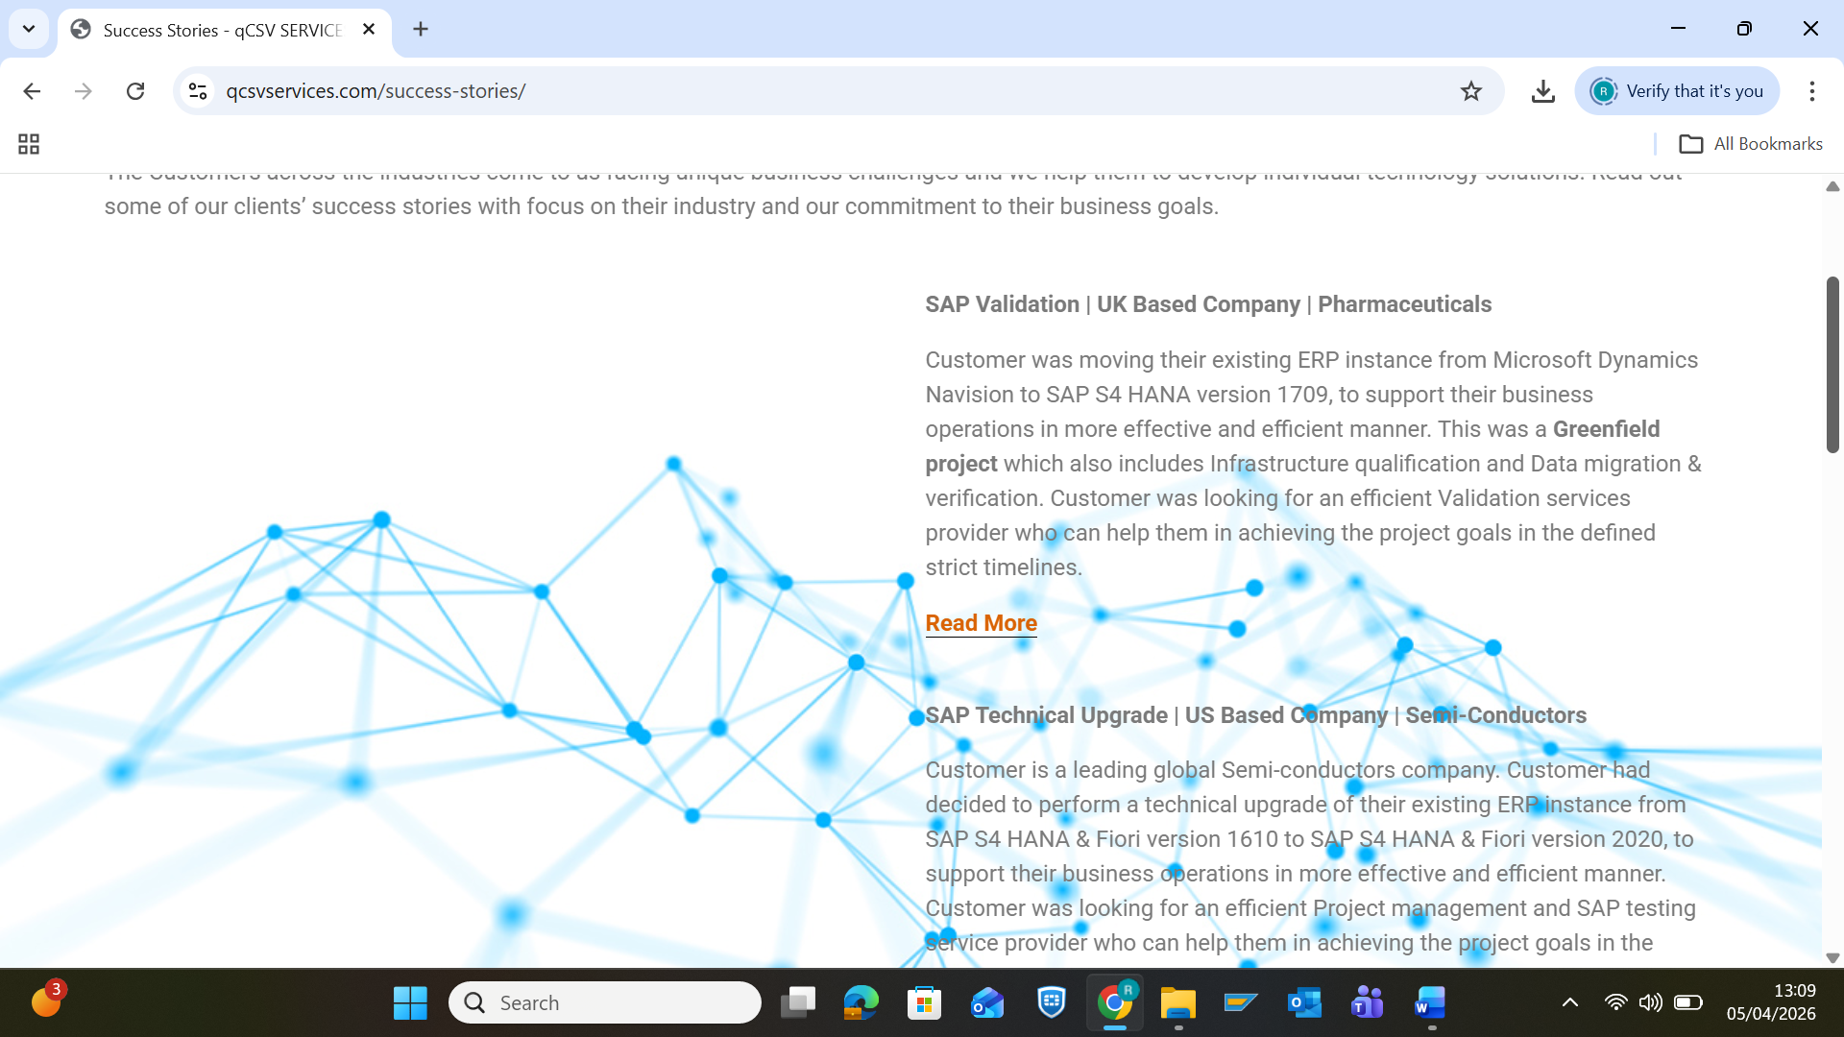
SAP Validation | UK Based Company | Pharmaceuticals
Customer was moving their existing ERP instance from Microsoft Dynamics Navision to SAP S4 HANA version 1709, to support their business operations in more effective and efficient manner. This was a Greenfield project which also includes Infrastructure qualification and Data migration & verification. Customer was looking for an efficient Validation services provider who can help them in achieving the project goals in the defined strict timelines.
Read Less
Solution provided:
QCSV Services leaded the engagement by deploying dedicated validation professionals skilled in the required areas, to perform Prospective Validation as per GAMP5 guidelines for the logistic modules. In a nutshell, as part of the service, we -
1. Developed the project templates from Concept to retirement phase.
2. Developed the validation deliverable’s throughout the project lifecycle, starting from Project plan till Validation summary report & System release certificate.
3. Developed the Master test plan covering the test strategy & test scenarios for across the SAP modules.
4. Developed the test scripts (Infrastructure, IQ, OQ, Data migration & PQ).
5. Performed the testing of SAP modules in scope, as part of Integration testing & OQ.
6. Reviewed the validation deliverables such as Business blueprints, FS, TS, Post execution test scripts review.
7. Developed the business process flows for the applicable processes across the SAP modules in scope.
8. Developed SOPs related to IT and QA processes.
9. Developed the End user manuals and Work instructions, related to SAP modules and processes.
10. Imparted training’s on various areas - Computer system validation (CSV), Good documentation practice (GDP), Testing practices, and many more.

SAP Technical Upgrade | US Based Company | Semi-Conductors
Customer is a leading global Semi-conductors company. Customer had decided to perform a technical upgrade of their existing ERP instance from SAP S4 HANA & Fiori version 1610 to SAP S4 HANA & Fiori version 2020, to support their business operations in more effective and efficient manner. Customer was looking for an efficient Project management and SAP testing service provider who can help them in achieving the project goals in the defined strict timelines, with quality outcomes.
Read Less
Solution provided:
QCSV Services leaded the engagement by deploying dedicated Project management and SAP professionals skilled in the required areas. In a nutshell, as part of the service, we -
1. Carried out end to end Project management activities.
2. Developed the Master test plan covering the test strategy & test scenarios for across the SAP modules & associated processes.
3. Developed the test scripts (Unit, and Integration) across the SAP landscapes (Mock, Development, and Quality).
4. Performed manual testing of business processes for SAP modules in scope, as part of Unit and Integration testing across the SAP landscapes (Mock, Development, and Quality).
5. Identified the test scenarios across the sites and developed Integration test scripts using ‘Robotic process automation (RPA)’ automation testing tool called ‘TestMagic’.
6. Performed automation testing of integrated scripts using ‘TestMagic’ automation tool in the Quality server.
7. Developed the ‘Cutover plan’ for the technical upgrade.
8. Developed the Issue tracker along with control implementation and monitoring until its closure.

LIMS Validation | US Based Company | Pharmaceuticals
Customer had decided to implement the LIMS software, to manage its laboratories activities and operations, such as - ‘Registration of a sample and its respective information, the tracking of the sample, the used equipment in the analysis of the sample along with its quality control, the storage of data, the report of the analysis’ and likewise.
This is a Greenfield project which also includes Infrastructure qualification and Data migration & verification. Customer was looking for an efficient Project Management and Validation services provider who can help them in achieving the project goals and completion on time.
Read Less
Solution provided:
QCSV Services leaded the engagement by deploying dedicated Project management and Validation professionals skilled in the required areas, to perform Prospective Validation as per GAMP5 guidelines. In a nutshell, as part of the service, we -
1. Developed the project templates.
2. Developed the validation deliverable’s throughout the project lifecycle, starting from Project plan till Validation summary report & System release certificate.
3. Developed the Master test plan covering the test strategy & test scenarios for LIMS modules / processes.
4. Developed the test scripts (Infrastructure, IQ, OQ, Data migration & PQ).
5. Performed the testing of business processes in scope and associated interfaces.
6. Reviewed the validation deliverables such as - Functional Specifications, Operational manuals, Post execution test scripts review.
7. Imparted training’s on various areas - Computer system validation (CSV), Good documentation practice (GDP), Testing practices, and many more.

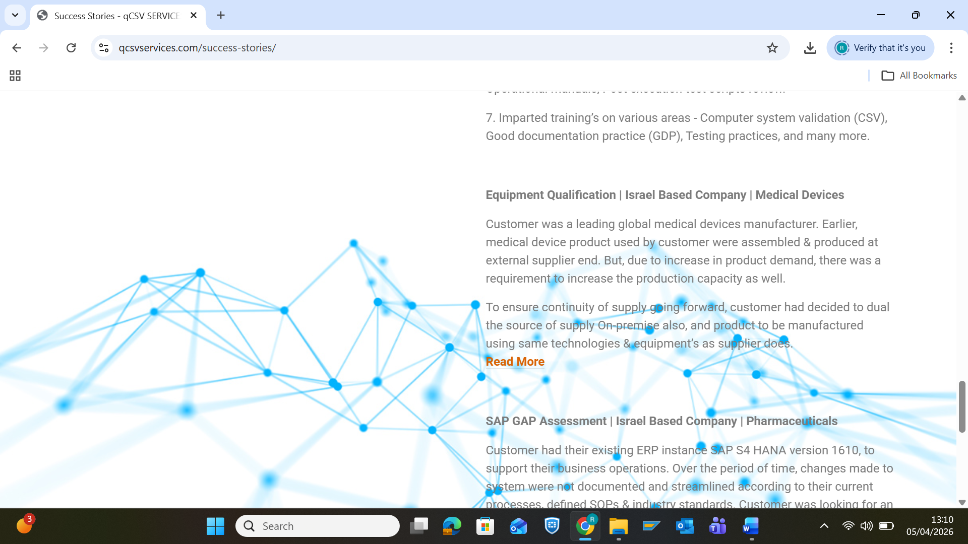
Equipment Qualification | Israel Based Company | Medical Devices
Customer was a leading global medical devices manufacturer. Earlier, medical device product used by customer were assembled & produced at external supplier end. But, due to increase in product demand, there was a requirement to increase the production capacity as well.
To ensure continuity of supply going forward, customer had decided to dual the source of supply On-premise also, and product to be manufactured using same technologies & equipment’s as supplier does.
Read Less
The customer was looking for an efficient Validation services provider who can help them in qualifying the equipment’s on-time and streamline the process.
Solution provided:
QCSV Services leaded the engagement by deploying Validation professionals skilled in the required areas. In a nutshell, as part of the service, we -
1. Developed the equipment process flows.
2. Developed the validation deliverable’s throughout the project lifecycle, starting from Validation master plan till Validation summary report.
3. Developed the test scripts (FAT, SAT, OQ, & PQ).

SAP GAP Assessment | Israel Based Company | Pharmaceuticals
Customer had their existing ERP instance SAP S4 HANA version 1610, to support their business operations. Over the period of time, changes made to system were not documented and streamlined according to their current processes, defined SOPs & industry standards. Customer was looking for an efficient Services provider who can help them in performing the GAP assessment of ERP system with respect to changes, current processes & SOPs, provide necessary recommendations to identified gaps.
Read Less
Solution provided:
QCSV Services leaded the engagement by deploying dedicated professional (s) skilled in performing gap assessments. In a nutshell, as part of the service, we -
1. Understand the customer ERP business processes.
2. Reviewed the existing validation / documentation package, SOPs of customer.
3. Performed testing of GxP business processes / functions and control assessments.
4. Identified the gaps in existing validation package and SOPs (IT & QA).
5. Identified the observation / gaps in processes & its controls.
6. Prepared the GAP assessment report along with recommendation to identified gaps for their closure.

SOP Preparation | Israel Based Company | Pharmaceuticals
Customer had implemented an ERP software SAP S4 HANA version 1610, to support their business operations. Customer was looking for an efficient Services provider / IT partner who can help them in preparing and delivering the SOPs, Work instructions and End user manuals for SAP modules and associated business processes in scope (i.e. Modules are - MM, PP, SD, QM, PM, FICO and WM) within crunch timelines.
Read Less
Solution provided:
QCSV Services leaded the engagement by deploying dedicated validation professionals skilled in areas of SOPs, Work instructions and End user manuals preparation and having an extensive knowledge of SAP processes & functions. As part of the service, we -
1. Understand the customer business processes across the modules in scope.
2. Developed the SOPs, Work instructions and End user manuals related to SAP modules and associated business processes.

Validation of Empower 3 system | US Based Company | Pharmaceuticals
Customer is a leading global pharmaceuticals company. Customer was moving their existing IT infrastructure from Cloud to a physical infrastructure setup, along with upgrading their existing Empower system. Customer was looking for an efficient a Validation service provider who can help them in achieving the project goals, with quality outcomes.
Read Less
Solution provided:
QCSV Services leaded the engagement by deploying skilled validation professionals in the area of Empower validation. In a nutshell, as part of the service, we -
1. Carried out end to end validation activities for Empower 3 validation.
2. Developed the validation deliverables starting from Concept to the Project phase.
3. Developed the Data migration and verification protocol.
4. Supported the client team members during test executions (i.e. IQ, OQ and PQs).

